**1. Display greet message using the system time.**

h=`date +%H`

if [ $h -gt 0 -a $h -lt 12 ]

then

greet=&quot;Good Morning&quot;

elif [ $H -gt 12 -a $h -lt 16 ]

then

greet=&quot;Good Afternoon&quot;

else

greet=&quot;Good Evening&quot;

fi

echo $greet

https://lh7-rt.googleusercontent.com/docsz/AD_4nXeEGRLE95bZfSUFbXN9Vs_8nznwaJDTL3cJwFiGkioUG_UmIOp_t23vt9d97dCgo8snxR1yPB5WSq4kvgxuQSvXIW1XEjYd_f1Xmk2G637uBMv64vhp_m4rigmQyO5vPDMBsVkHaRkjGwzl3y5UJq3f8c0mj5h8SFPy3U7M?key=t9NNz92UCsiOb9xCnX1TnA

**2. Find the factorial of a given number.**

echo "Enter a number"

read n

fact=1

while [ $n -gt 0 ]

do

fact=`expr $n \* $fact`

n=`expr $n - 1`

done

echo "Factorial is $fact"

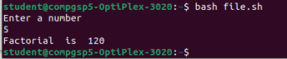

**3. Generate the fibonacci series for the number of terms entered by the user.**

 echo "enter a number:"

read n

next=0

first=0

second=1

echo "Fibonacci Series: "

for((i=1;i<=n;i++))

do

echo "$first"

next=$((first + second))

first=$second

second=$next

done

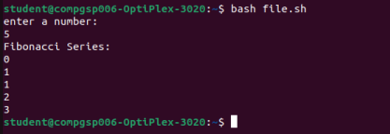

**4. To print the number table.**

echo "Enter a number"

read n

echo "The multiplication table of $n is : "

for ((i=1;i<=10;i++))

do

tmp=`expr $i \* $n`

echo "$n * $i = $tmp"

done

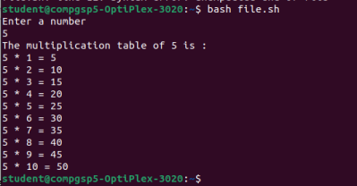

**5. To display square of first 20 numbers.**

echo "The square of first 20 numbers are : "

for ((i=1;i<=20;i++))

do

tmp=`expr $i \* $i`

echo "$i * $i = $tmp"

done

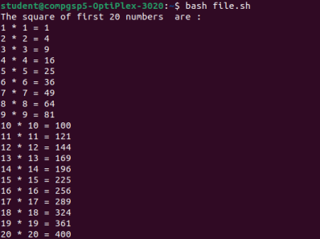

**6. To print the largest of 3 numbers entered by the user.**

echo " enter three number:"

read a b c

if [ $a -gt $b -a $c ]

then

echo " A: $a is greater "

elif [ $b -gt $c ]

then

echo " B: $b is greater "

else

echo "c: $c is greater "

fi

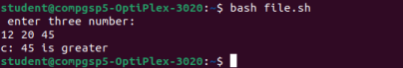

**7. To reverse a number.**

echo " Enter a number "

read n

result=0

while [ $n -gt 0 ]

do

tmp=`expr $n % 10`

n=`expr $n / 10`

result=`expr $result \* 10 + $tmp`

done

echo $result

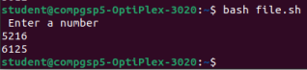

**8. To reverse a string.**

echo "Enter a string"

read str

len=`echo $str | wc -c`

while [ $len -gt 0 ]

do

rev=$rev`echo $str | cut -c $len`

len=`expr $len - 1`

done

echo $rev

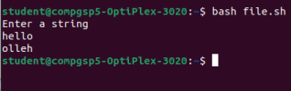

**9. Check whether the entered number is odd or even.**

echo "enter a number:"

read n

if [ `expr $n % 2` -eq 0 ]

then

echo "number $n is even"

else

echo "number $n is odd"

fi

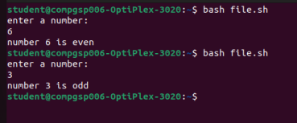

**10. Check Whether given year is leap year or not.**

echo "enter a year:"

read year

if [ `expr $year % 400` -eq 0 ]

then

echo "leap year"

elif [ `expr $year % 4` -eq 0 ]

then

echo "leap year"

else

echo "not a leap year"

fi

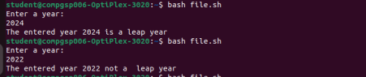

**11. To print all the prime numbers less than 20.**

a=2

while [ $a -le 20 ]

do

i=2

flag=0

while [ $i -le `expr $a / 2` ]

do

if [ `expr $a % $i` -eq 0 ]; then

flag=1

break

fi

i=`expr $i + 1`

done

if [ $flag -eq 0 ]; then

echo $a

fi

a=`expr $a + 1`

done

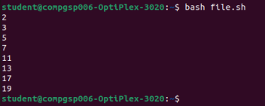

**12. To check if the entered string is palindrome or not.**

echo "Enter a string"

read str

len=`echo $str | wc -c`

while [ $len -gt 0 ]

do

rev=$rev`echo $str | cut -c $len`

len=`expr $len - 1`

done

echo $rev

if [ $str == $rev ]

then

echo "The enetered string is a palindrome"

else

echo "The entered string is not a palindrome"

fi

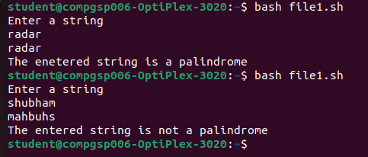

**13. Using switch case print the capitals given the state name.**

echo "A. Goa"

echo "B. Maharastra"

echo "C. Karnataka"

echo "D. Tamil Nadu"

echo "E. Gujarat"

echo "Enter your choice: "

read choice

case $choice in

a|A) echo "Goa's capital is Panaji";;

b|B) echo "Maharastra's capital is Mumbai";;

c|C) echo "Karnataka's capital is Bangalore";;

d/D) echo "Tamil Nadu's capital is Chennai";;

e|E) echo "Gujarat's capital is Ahmedabad";;

*) echo "Invalid Choice";;

esac

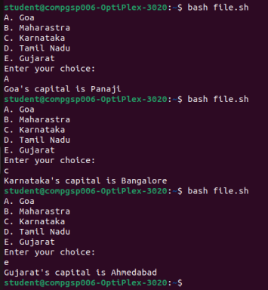

1. **Write shell script to generate following series: 20, 22, 18, 20, 16, 18, 14, 16.**

a=20

b=22

echo -n "$a $b"

for((i=1;i<=3;i++))

do

a=`expr $a - 2`

b=`expr $b - 2`

echo -n " $a $b "

done

echo

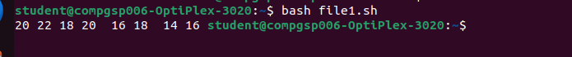

**15. Append content to a file provided file name exists and it has write permission.**

printf "Enter file name: "

read file1

if [ -f "$file1" ]

then

if [ -w "$file1" ]

then

echo "File Exits!"

echo "Enter data to append"

cat >> $file1

else

echo "Not writable"

fi

else

echo "File does not exits"

fi

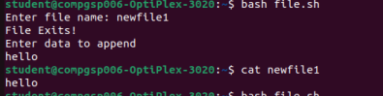

**16. Generate the series: 1,3,2,4,3,5,4,6,.....**

printf "Enter the number of term: "

read num

term1=1

term2=3

for((i=4;i<num;i++ ))

do

 printf "$term1 $term2 "

 term1=$((term1 + 1))

  term2=$((term2 + 2))

done

echo " "

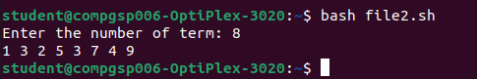

1. **Write a shell script to prompt user to enter 2 numbers and perform various arithmetic operations using switch statement.**

echo "enter 2 numbers"

read a b

echo "enter choice: 1.Add 2.Sub 3.Mul 4.Div 5.Mod"

read choice

case $choice in

1) result=`expr $a + $b`;;

2) result=`expr $a - $b`;;

3) result=`expr $a \* $b`;;

4) result=`expr $a / $b`;;

5) result=`expr $a % $b`;;

*) echo "invalid option"

esac

echo $result

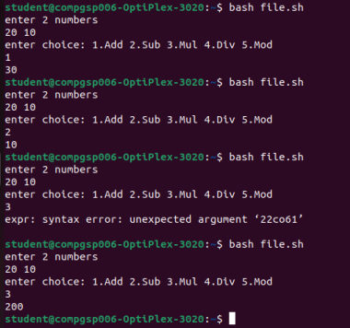

1. **To sort given numbers in descending order.**

printf "Enter number of elements: "

read n

echo "Enter elements"

for (( i=0; i<$n; i++ ))

do

read num[$i]

done

echo ""

echo "Entered elements are:"

for (( i=0; i<$n; i++ ))

do

printf "${num[$i]} "

done

echo ""

for (( i=0; i<$(($n-1)); i++ ))

do

for (( j=0; j<$(($n-$i-1)); j++ ))

do

if [ ${num[$j]} -gt ${num[$(($j+1))]} ]

then

temp=${num[$j]}

num[$j]=${num[$(($j+1))]}

num[$(($j+1))]=$temp

fi

done

done

echo ""

echo "Sorted elements are:"

for (( i=0; i<$n; i++ ))

do

printf "${num[$i]} "

done

echo ""

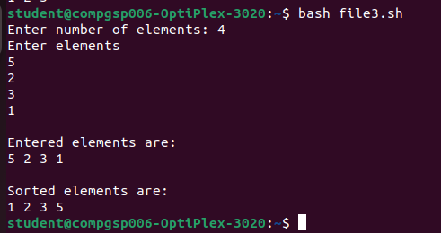

1. 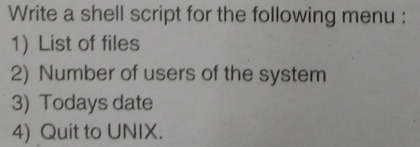

while [ 1 ]

do

echo "Select a Shell Script"

echo "A)List of files B)Number of users of the system C)Today's date D)Quit to UNIX"

echo "Enter your choice "

read choice

case $choice in

a|A)ls

echo;;

b|B)who

echo;;

c|C)date

echo;;

d|D)exit

echo;;

*)echo"invalid input"

esac

done

1. 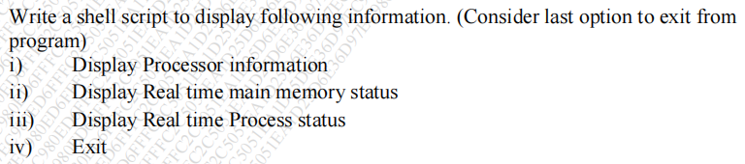
2. 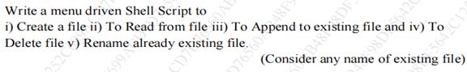
3. 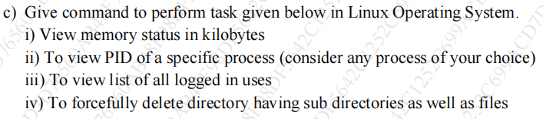

23. Display the following patterns :

**\* * * * \***

**\* * * \***

**\* * \***

**\* \***

**\***

for ((i=5;i>=1;i--))

do

    for((j=1;j<=i;j++))

  do

 printf " * "

done

   echo ""

   done

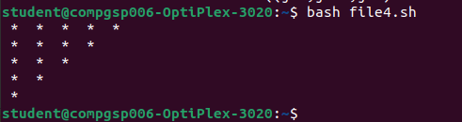

**1 2 3 4**

**2 3 4**

**3 4**

**4**

for ((i=1; i<=4; i++))

do

  for ((j=i; j<=4; j++))

  do

    echo -n "$j "

  done

  echo ""

done

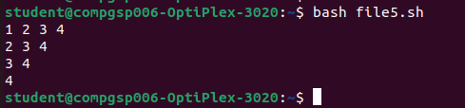

**1**

**2 2**

**3 3 3**

**4 4 4 4**

for ((i=1; i<=5; i++))

do

  for ((j=1; j<=i; j++))

  do

    echo -n "$i "

  done

  echo ""

done

